CALCULATING THE AVERAGE ACCELERATION
a= v-u
t
a=the average acceleration.
V=final speed
U=starting speed
t=time
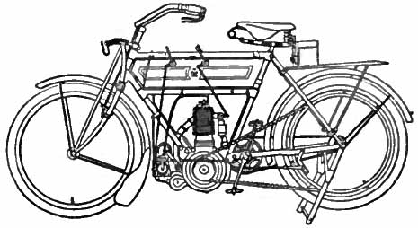
Bill’s motor bike can accelerate from 0kph to 100kph in 10 second. What is his average acceleration?
a= v-u
t
a= 100 - 0
10
a= 10Km/h/s
So every second his motor bike gets 10km/h faster.

Car | Final speed  (t) | Starting speed  (u) | Calculation  a= v-u  t | Average acceleration  (a)
Nissan
Bmw
Volkswagen
Ford
Holden
Honda
Toyota

